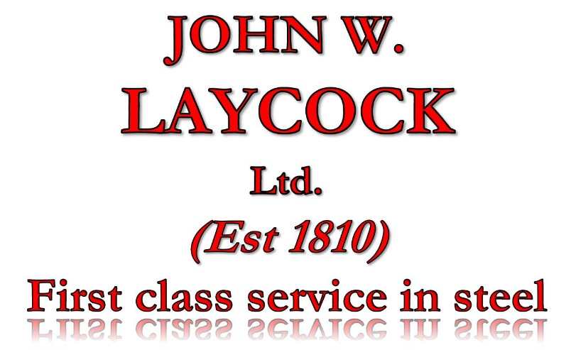
STOCKBRIDGE WORKS
BRADFORD ROAD
KEIGHLEY
WEST YORKSHIRE
BD21 4EH

TEL. 01535 667033
FAX. 01535 611160
EMAIL. sales@johnwlaycock.co.uk
WEB. www.johnwlaycock.co.uk

Statement of compliance with the Modern Slavery Act 2015

Introduction
JOHN W. LAYCOCK Ltd. strongly supports the Modern Slavery Act 2015 and acknowledges its responsibility to comply with it.
JOHN W. LAYCOCK Ltd. is committed to ensuring that both the organisation and its supply chains are free of slavery and human trafficking, and that the necessary due diligence is undertaken to provide assurance of this.

Procurement
JOHN W. LAYCOCK Ltd.’s procurement practices incorporate processes to ensure that our suppliers comply with the requirements of the Modern Slavery Act 2015.
New suppliers are analysed to assess the risk of non-compliance with the Act and, if considered necessary, are asked to provide further assurances.
Depending on the type of goods and services being provided and the depth of the supply chains involved, further due diligence may be undertaken.

Assurance
JOHN W. LAYCOCK Ltd. is satisfied that, over the past year, there has been no evidence of any connection with modern slavery or human trafficking, either within the organisation or through any of our suppliers or sub-contractors.

Continued commitment
The Directors and Management Team of JOHN W. LAYCOCK Ltd. will ensure that the implementation of this policy is reviewed and updated as necessary.

Mark Sugden
Director

